
Storage Devices Task

Storage Device | Size | Description | Advantages | Disadvantages

Hard Disk
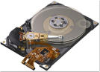

Magnetic tape backup
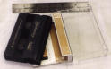
CD-ROM
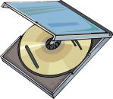

CD-RW

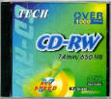
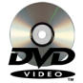
DVD

Flash Memory Stick
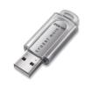

Network storage
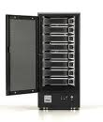

Online storage


Solid State Devices (SSD
