
Theory Notes Task: Output Devices

Make sure that you are familiar with all of the information detailed in this booklet. There are a number of tasks for you to carry out, be sure to read the information fully whilst completing the tasks. You could be asked about any of this in the test!

Use the theory notes in from the teach-ict.com site to help you complete this booklet.

TASK 1: OUTPUT DEVICES

Output devices let you see data that has been processed or is stored on the hard disk or any other storage media. A monitor lets you see data on the screen, a printer produces a paper copy that you can hold and read.

Complete the table below:

Output device | Description | Extra fact you found out
Monitor  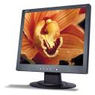 | A monitor is the most commonly used output device. It allows you to see the document that you are working on. As you make changes to the document, the monitor automatically updates so that you can see your work.
Laser printer
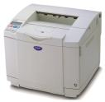
Ink-Jet printer
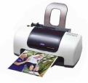

Digital projector

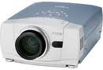
Plotter
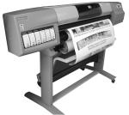

Speakers

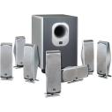
Headphones
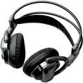
LED Lights
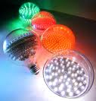

TASK 2: FILL IN THE BLANKS

Copy the sentences below and complete the blanks using words from the list.
You should use each word only once.

LAPTOP | PIXELS | SIZES | SCREEN
INCH | OUTPUT | DOTS | EXPENSIVE

Monitors
These are the most common _____________device. Sometimes they are called a ___________ instead. All desktop computers have a separate monitor, but a ___________ computer will have a monitor which is attached by hinges.
Monitors come in different ___________ but the larger they are, the more ____________ they tend to be.
The picture on a monitor is made up of thousands of tiny coloured ___________ called ____________The quality of a monitor depends on the number of pixels per _________.

Printers
CARTRIDGES | INK-JET | CARBON | HARD
LASER | RIBBON | TONER

Printers are useful for creating a _________copy of your work. There are two main types of printer:
- Laser printer
- Ink-jet printer
____________ printers work much like a photocopier, powdered ink is fused onto paper by heat and pressure. They produce a very high quality output, are quiet and fast, although quite expensive to buy. They use __________rather than cartridges.
___________ printers are cheaper to buy, offering black and white or colour printing with reduced levels of quality and speed. The nozzles fire a jet of liquid ink through tiny holes, hence the name, ‘ink-jet’. The ink is stored in______________.

TASK 3: CHOOSE THE MOST SUITABLE OUTPUT DEVICE

Which output device would you recommend for the following tasks:

To produce a large number of letters in high quality
Producing very large sheets such as blueprints
Producing a small number of coloured leaflets
Looking at changes that you are making to the document you have open
Display a presentation to an audience
Listen to music with friends

END OF WORKSHEET

