INPUT DEVICES

1. List five types of manual input device:

1…………………………………………………………….
2…………………………………………………………….
3…………………………………………………………….
4…………………………………………………………….
5…………………………………………………………….

2. Draw outlines around and label the following section of this keyboard to show the:
- Function Keys
- Alphabet Letters
- Numeric Keypad
- Cursor movement and editing keys

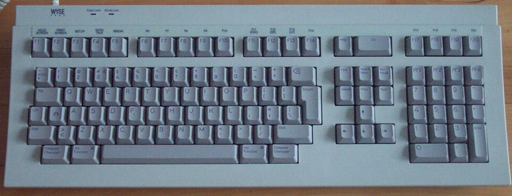

3. Some people can get repetitive strain injury (RSI) from using keyboards. Find an image of an ‘ergonomic keyboard’ and paste it here:

4. Explain how an ergonomic keyboard can reduce the risk of RSI.
………………………………………………………………………………………………………………………………………………………………………………………………………………………………………………………………………………………………………………………………………………

5. Find a picture of a ‘concept keyboard’ and paste it here.

6. Give two examples of where a concept keyboard might be used.

1…………………………………………………………….
2…………………………………………………………….

7. Find pictures of a mouse, a cordless mouse and a trackball mouse and paste them here.

8. List some common terms that people say when using a mouse.

1…………………………………………………………….
2…………………………………………………………….

3…………………………………………………………….

9. Find out about the different types of scanners that are available. Write a short section here to explain the differences.

