
Input Devices Theory Notes Task

An input device is anything that is used to get data INTO the computer. Write a couple of sentences to describe the following input devices.

Input device | Description | Extra fact you found out
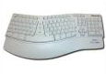  Keyboard | A keyboard is used to enter text into the computer. It has a set of alphabet keys, number keys and function keys.  Keyboards usually use a QWERTY layout.  If you have wrist pain you can get an ‘ergonomic keyboard’
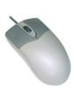
Mouse
Touchpad

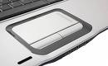

Joystick

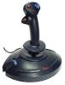

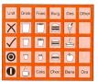
Concept Keyboard
Touch screen
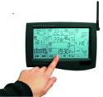
Scanner
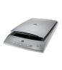

Graphics tablet
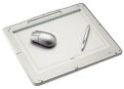
Microphone

Webcam

Barcode Reader

Optical Mark Reader

Optical Character Recognition

Magnetic stripe reader

Remote controls

Biometric Devices
Sensors

